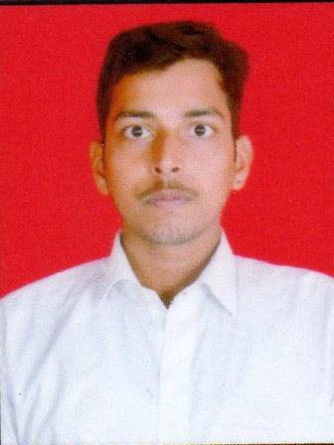
Ashutosh Rai
Mobile: 8299194458
E-Mail: ashutosh.rai10@gmail.com

- Seeking an entry level assignment in Sales and Marketing / Advertising / Public Relations with an organisation to bring my strong sense of dedication, motivation, and responsibility to the organization, and to utilize my skill & qualifications.

An Overview

- MBA (Marketing and Information Technology) professional from IIMT University, Meerut.
- A self-directed learner with the ability to work independently and meet deadlines.
- A self-motivated individual with commitment towards quality & efficiency and initiative to achieve the set goals.

Educational Credentials
- Completed EXL Certified Transaction Process Executive Course from EduBridge Learning Pvt. Ltd.
- MBA (Marketing & Information Technology) from IIMT, College Of Commerce and Management, Meerut, affiliated to IIMT University, Meerut.
- BCA (School of Management and Science) from SMS College, Varanasi affiliated to MGKVP University, Varanasi in 2018.
- 12th from, PMMMIC School, Ghazipur affiliated to UP Board in 2015.
- 10th from Glenhill School, Varanasi affiliated to CBSE Board in 2012.

Work Experience

- 60 days Internship (June2019 – August 2019) in Toyota (Project on Customer Relationship Management).
- In “Softyug” as Marketing executive (nearby 7 months) .
- In “PSR Diagnostics Pvt. Ltd.” as Sales executive and Service engineer, ( joined it on 2 Feb 2020 and still working) .

Positions of Responsibilities
- I have been Co-ordinator of Organising & Administrative Team of CULTURAL PROGRAMMS from 2018-2019 Organised by college every year.
- I have been active member and Co-ordinater of Cultural and other Programmes held in college.

Presentations

- Successfully Given presentations on the following topics:
  - Entrepreneurship.
  - Retail Stores
  - Sales Techniques of an Organization
  - Rural Marketing V/s Urban Marketing
  - Interview & Group Discussion – Types and Styles

Project

- Research paper on “E-commerce” in National seminar.
- Project on “Library management system” software on “C” language.
- Project on “Customer relationship management”.
- Project on “Traditional marketing / Digital marketing”.

IT Skills/Languages

Operating System - MS office
Language - Hindi & English
Computer language - C, C++, Java

Interests/Hobbies

- Travelling, Adventure,& various sports etc.

Personal Vitae
Date of Birth - 15thJuly 1997
Address - Amara Akhri Bypass Varanasi, U.P (221106)
Father Name - Mr Lalji Rai
Mother Name - Mrs Lalmani Rai

Declaration

I hereby declare that all the information provided above is true and correct to the best of my Knowledge.

Date: / /
Place: Meerut Ashutosh Rai

